Fireball Data converter script – User guide

Version 4.42, 19th October 2026

Overview

This script converts fireball observations between the data file formats used by different fireball-camera networks. It reads FRIPON, UFOAnalyzer, MetRec, Desert Fireball Network (DFN/UKFN), RMS, CAMS, AllSkyCams and Global Fireball Exchange (GFE) files, and writes GFE, UFO, DFN, FRIPON, AllSkyCams or Excel CSV files. Its main purpose is to enable the sharing of data between fireball networks, either through the Global Fireball Exchange (GFE) format or by converting to one of the other formats.

1. How to use the script

The script is written in Python. First install Anaconda with Jupyter (available from the internet), then use Jupyter to open the script. You will need to install the package "xmltodict" before you start.

Running the script

From the Jupyter menu, chose “Kernel/Restart and Run All”. There will then be a delay of up to a minute while nothing happens. Don’t panic, it’s just loading large libraries from the internet (specifically, MetRec-specific utilities from ESA). Just wait until a “file/open” dialogue appears. Intervening won’t speed it up!

Reading the data that you want to convert

A “file open” dialogue box will appear, asking for the name of a file containing meteor data to convert. It can take any of the data types listed above. The script is smart enough to work out what kind of data it is opening. If however you want to narrow down the choice of data files so that it is easier to find the one that you want, use the dropdown menu in the bottom right corner of the file dialogue box.

Please note that if you are converting from a FRIPON *.met or *.zip "Processed Multiple Event" file, or from an AllSkyCams file, an active internet connection is helpful so that the current observatory-location list can be downloaded from the SCAMP GitHub repository. If no internet connection is available the script falls back to a small built-in list of UK and Ireland stations, so observations from outside the UK and Ireland will be missing their site coordinates.

Some input formats need one or more companion files to be in the same folder as the data file. For RMS "FTP_detect" data the script looks for the camera file "platepars_all_recalibrated.json"; for CAMS "FTP_detect" data it looks for a "CAL*.txt" calibration file; and for MetRec data it looks for the matching "*.log" file. If it cannot find the file it needs, it will open a further dialogue box asking you to select the companion file.

Writing your converted data

Once you’ve selected your input file, you will be prompted for the output file type that you want to produce. Choices are “1=Global Fireball Exchange (GFE), 2=UFO, 3=DFN/UKFN, 4=FRIPON, 5=AllSkyCams, 9=ExcelCSV”.

After that, you will be prompted for an output file name. Please note that the “file output name” dialogue can take a while to load and then is sometimes hidden by other windows on the screen, so you might see it first by looking in the notification tray at the bottom of your screen.

If there is just one meteor in the input file and the output type is Global Fireball Exchange format, DFN, AllSkyCams or Excel CSV, then just a single output file is produced, and the script will prompt you for a suitable name for that file.

Whenever the input file contains more than one meteor, output will be presented as a zipped file the script will prompt you for the name of the ".zip" file to be written. UFO and FRIPON output is always presented as a zipped file, even for a single meteor.

As noted above, the "file output name" dialogue box often takes a while to load and then appears behind the other windows, so look for a flashing icon in the system tray if you do not see the dialogue box within a few seconds.

Once you choose the output file/zip name, the script will write the file then display “finished”.

2. What the script produces

The data files produced by the script depend on the answer to the prompt “1=Global Fireball Exchange (GFE), 2=UFO, 3=DFN/UKFN, 4=FRIPON, 5=AllSkyCams, 9=ExcelCSV” as below. They also depend on the number of meteors in the input file. Let’s assume there are “N” meteors in the data that has been read, where N >= 1:

- Global Fireball Exchange format – an *.ECSV file for each of the N meteors. Each output file is a single-meteor file in an Astropy ECSV table format;
- UFOAnalyzer’s *A.XML file - a single-meteor file in XML format for each of the N meteors, plus a summary CSV file in R91 format;
- Desert Fireball Network (DFN/UKFN) – an *.ECSV file, which is a single-meteor file in an Astropy extended CSV table format, for each of the N meteors;
- FRIPON/SCAMP’s *.met file, for each of the N meteors, a single-meteor *.met file in SExtractor extended CSV table format, plus a small text file containing observatory location;
- AllSkyCams – a *.json file, which is a single-meteor file in JSON format, for each of the N meteors; or
- Excel CSV – for each meteor a *.csv file suitable for reading in Excel, with labelling of metadata and date/time in Excel number format as well as in a Y,M,D,H,M,S format.

3. Data formats which are supported

In the diagram below, formats that the script can read are on the left, and those that it can write are on the right:

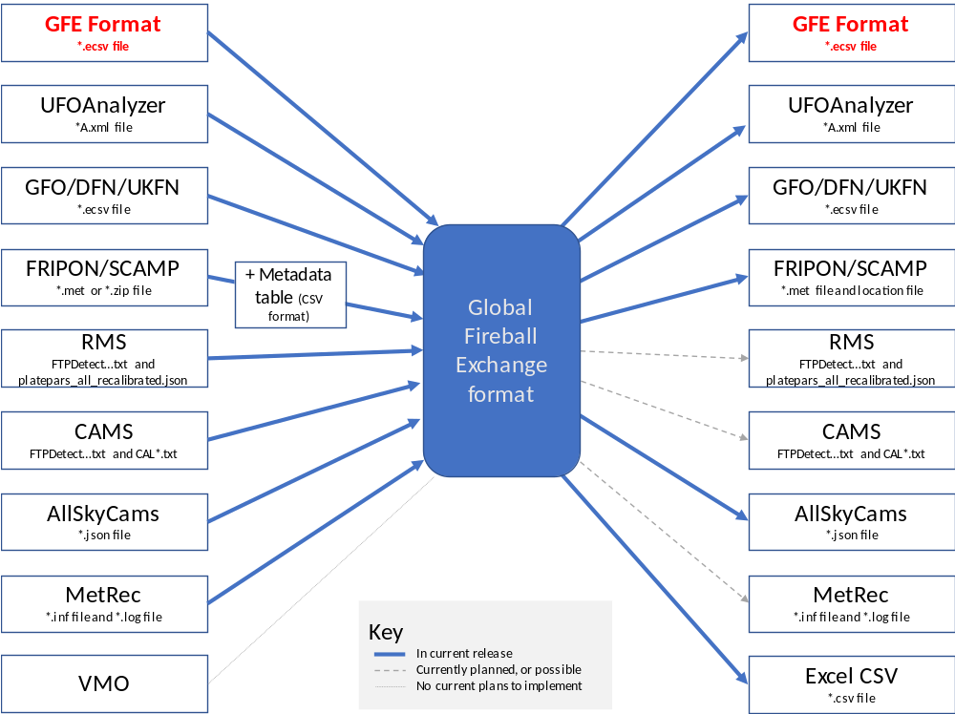

4. How the script works

The script reads Global Fireball Exchange format, DFN and FRIPON files as Astropy tables, and reads FRIPON "Processed Multiple Event" .zip files as a list of tables. It reads UFOAnalyzer files as XML, and reads AllSkyCams and RMS files as JSON. MetRec files are read using library routines (mrg_core) published by ESA and imported into the script. RMS "FTP_detect" and CAMS files are read line-by-line, as no library routine is suitable.

Once the file is read, about two dozen key pieces of metadata are picked out of the input and stored as an Astropy table. The point observation data for each frame or point in the observed image is also read and converted to a standardised form in the Astropy table. These data items are listed overleaf. The data for multiple meteors are stored as an array of Astropy tables.

If the input for each data point only contains RA and DEC, it is assumed to be J2000 data and so precession is calculated and a conversion to AZ ALT coordinates is done. Similarly, if only AZ and ALT are given, this is converted to RA and DEC in the J2000 reference frame. For RMS "FTP_detect" input, a fixed correction of 2.4 seconds is subtracted from every timestamp to allow for a known offset in RMS timing.

Once the output type is chosen, the array of tables is converted to the output type that you choose and is written by an Astropy table writing function (in the case of GFE or DFN output), as a standard JSON file in the case of AllSkyCams data or line-by-line for UFO, FRIPON and Excel CSV output.

5. Thanks and credits

Thanks to Hadrien Devillepoix of Desert Fireball Network for providing the DFN Read/write code which is incorporated (in altered form) into this notebook, and for the 2024 amendments (incorporated in version 4.42) of the code which reads UFO Analyzer files.

Substantial development work was carried out in June and July 2020 by Nicholas Pochinkov of Dunsink Observatory, Dublin and Trinity College, Dublin. This includes the MetRec, CAMS and RMS data-reading code and the multi-meteor and zip file capabilities.

RA/DEC Alt/Az conversion and precession code is taken from RMS on the Croatian Meteor Network’s GitHub site, copyright (c) 2016 Denis Vida.

The script is maintained by Jim Rowe of Fireballs Aotearoa, https://fireballs.nz/, jamesrowe999@gmail.com.

6. Bugs, and future developments

There may be ways to crash the script. If you find problems, please let me know. Even better, please fix the problems and make a pull request on the UKFAll GitHub page at https://github.com/UKFAll/standard
Changes in version 4.42: UFOAnalyzer (UFO) azimuths are south-referenced, and the script now converts them to and from the north-referenced (east-of-north) convention used by GFE and the other formats. Output in GFE/ECSV format now also includes default per-point astrometric and timing uncertainty columns (2 arcminutes and 3 milliseconds, based on DFN's conversion script) for camera data that does not supply its own uncertainty values. Finally, when a UFO file contains no RA/Dec (only Alt/Az), the RA and Dec are now computed from the Alt/Az rather than being left as zero.

Appendix – Variable names in “GFE” form, and their equivalents in the other formats.

Variable names in Global Fireball Exchange format are the same as in DFN format except where highlighted in orange, below.

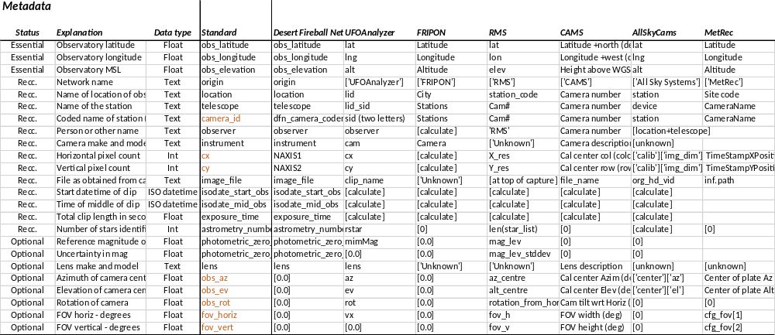

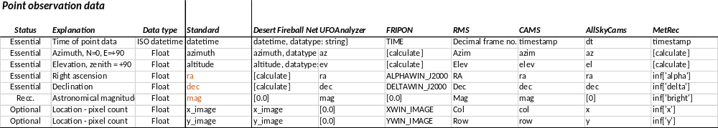

Note (v4.39): in the current script:
- the Standard/GFE key for the middle-of-clip time is isodate_calib; the table above lists it under its Desert Fireball Network name, isodate_mid_obs.
- The photometric_zero_point and photometric_zero_point_uncertainty fields are defined in the standard but are not written by the current version of the script.

